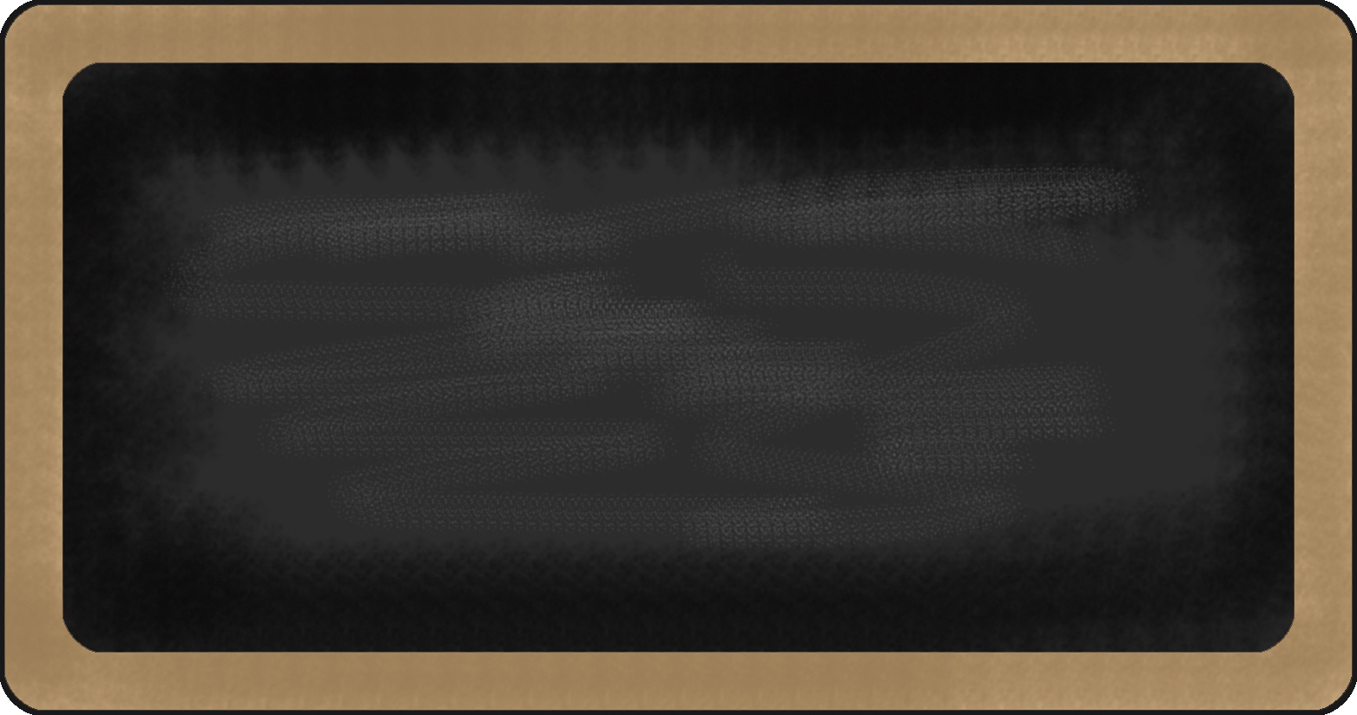
Sight Words

- A
- To
- You
- One
- Is
- The
- And
- See
- It
- I

Mrs. Damren and Mrs. Baxter’s News: September 8, 2015

Upcoming events

September 12th Extreme Fitness
September 14th first CARE club meeting
September 21-25 Fall Break
September 28th Care Club meeting

reading | Writing | Word | Math | Science | Social studies
- Good Night Moon | - Name writing  - Vocabulary from book | - Space | - Identifying numbers  - adding | - Stars/Sun | - Social interactions  

Notes from the teacher:
*New to class: Homework folders!
*Students must be in class by 8:00 or they will be counted tardy.
All parents must check in through the front office anytime they visit the school. Please look for visitor stickers.
Please practice sight words with your students nightly!

Happy Birthday to:

What we are learning this week:

Contact Information Mrs. Damren 770-443-8060 rdamren@paulding.k12.ga.us


